[today’s date]
[Your name]
[Your street address]
[Your city and state]

[Government official’s title followed by full name]
[official’s office street address]
[official’s office city and state]

RE: DON’T PUNISH PAIN Nationwide Rally April 7, 2018 12 p.m. EST

Dear [official’s title and last name],
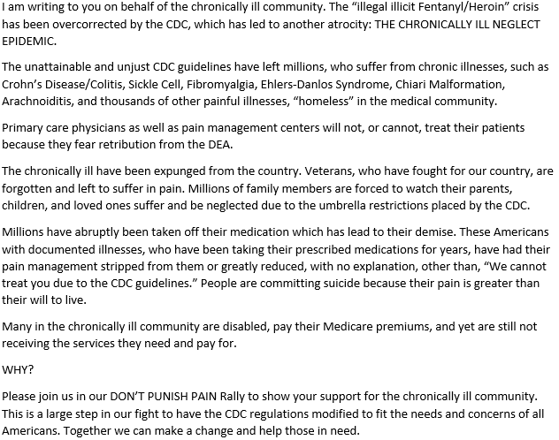
Best Regards,
[Your signature]

